**Title:**

*Loqal*

**Project Description**

We want to have a user input a popular artist, and then the program would respond with a local artist that is similar, along with any upcoming events the artist will appear at.

**User Story**

As a local music enthusiast, I would like to uncover local artist which sound like the commercial artists I listen to regularly, **SO** **THAT** I can support talented local artists.

**WireFrame**

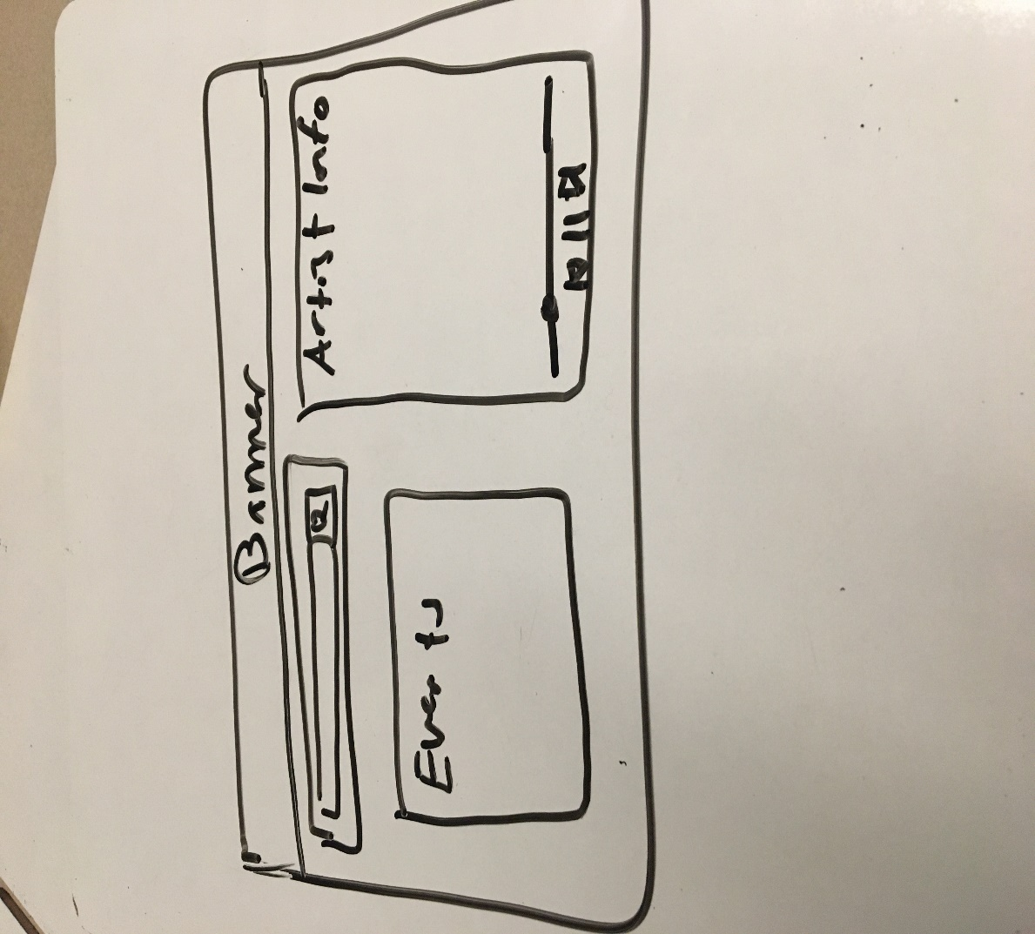

**API’s**

1. SpotifyAPI
2. MusixMatchAPI
3. Audd.ioAPI
4. soundcloudAPI
5. BandsinTownAPI

**Tasks**

1. Javascript Dynamic Generation
   1. Denisa
2. Styling
   1. Robbie
3. Data/API
   1. Ose

**Process**

* 1. Two separate paths
     1. Primary:
        1. Take the user input, input it into Spotify API, and then take that information and match it into soundcloud, and then the artist information and put it into bandsintown
     2. Secondary (Catch method)
        1. Go from the user input, to the musicxmatch api, to the audd.ioAPI, into soundcloud, into bandsintown.